SOND Social Organizations Networking for Development

NEWS LETTER – SOND - July & August 2019
nra;jp kly;

SOND epWtdj;ijg; gw;wp:-
SOND epWtdkhdJ Gjpa r%fk; xd;iw cUthf;Fk; Nehf;Fld; epiwNtw;Wg; gzpg;gsu; jpU.r.nre;Juhrh mtu;fshy; 1998 Mk; Mz;L mk;ghiw khtl;lj;jpy; Muk;gpf;fg;gl;L gpd;du; tl fpof;fpd; Vida khtl;lq;fspy; fpisfisf; nfhz;L r%f kl;lj;jpy; khw;wq;fis Vw;gLj;Jtjw;fhf tpopg;Gzu;T nraw;ghl;bYk;> r%f mgptpUj;jp nraw;ghLfspYk; <Lgl;L tUfpd;w xU mur rhu;gw;w epWtdkhFk;. vkJ epWtdk; Muk;gpf;fggl;L 20 tUlq;fis fle;J gzpfisj; njhlUtjw;fhf 21 MtJ tUlj;jpy; vl;lhtJ khjj;ij fle;Js;Nshk;.

,yq;ifapy; kdpj tpahghuj;jpw;F vjpuhd Kaw;rpfis tYg;gLj;jy; nraw;jpl;lj;jpD}lhf ey;Y}u; gpuNjr nrayf mur mjpfhupfSf;fhd xU ehs; gapw;rp

,yq;ifapy; kdpj tpahghuj;jpw;F vjpuhd Kaw;rpfis tYg;gLj;jy; nraw;jpl;lj;jpD}lhf ey;Y}u; gpuNjr nrayf mur mjpfhupfSf;fhd xU ehs; gapw;rp newpahdJ aho; khtl;l nrayfj;jpy; eilngw;wJ.
,g; gapw;rp newpapy; fpuhkNritahsu;fs;> gpuNjr nrayf cj;jpNahfj;ju;fs;> kw;Wk; FLk;g ey cj;jpNahfj;ju;fs; MfpNahu; fye;J nfhz;ldu;.
,g;gapw;rpapy; tsthsu;fshf nrhz;l; epWtd epiwNtw;Wg; gzpg;ghsu; jpU.r.nre;Juhrh mtu;fSk; ntspehl;L Ntiytha;g;G mgptpUj;jp cj;jpNahfj;ju; jpUkjp.FkNurd; Nyhrdh mtu;fSk; fye;Jnfhz;ldu;.
,g;gapw;rpapy; kdpj tpahghuk; njhlu;ghd tplaq;fs; gq;Fgw;Wdu;fSf;F njspTgLj;jg;gl;lJ.
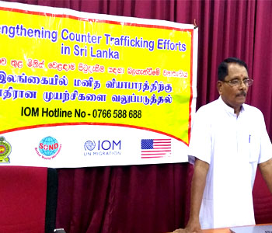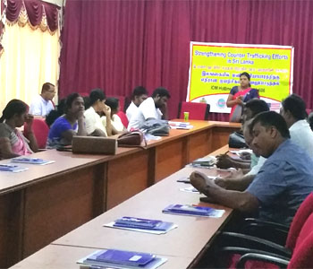
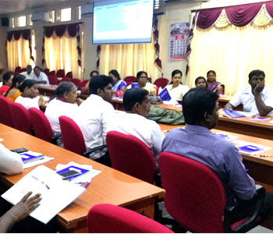

Contact Information:
Director :- Mr.S.Senthurajah
T.P no :- 021 222 6700,
077 3314262
E-mail :- senthu@eureka.lk
Address :- 18/10 Wymen road,
Nallur,
Jaffna.
& R.K.M.Road, Akkaraipattu.

SCORE jpl;lj;jpd; fpuhk kf;fSf;fhd jpl;lkply; $l;lk;

Njrpa rkhjhdg; Nguitapd; r%f xw;Wik kw;Wk; ey;ypzf;f eltbf;ifr; nraw; jpl;lj;jpd; fPo; njy;ypg;gis gpuNjr nrayfg;gpuptpy; njupT nra;ag;gl;l 5 fpuhkq;fspd; vjpu;fhy nraw;ghLfs; njhlu;ghd fye;Jiuahly; nrhz;l; epWtdj;jpd; epiwNtw;Wg; gzpg;ghsu; jpU.r.nre;Juhrh mtu;fspd; jiyikapy; nfhy;yq;fyl;b kw;Wk; gyhyp fpof;F Mfpa fpuhk Nrtfu; gpuptpy; 5 fpuhkq;fisAk; cs;slf;fpa fye;Jiuahly; eilngw;wJ. NkYk; ,f; fye;Jiuahlypy; 5 fpuhkq;fis Nru;e;j mur cj;jpNahfj;ju;fSk;> r%f xw;Wik kw;Wk; ey;ypzf;f eltbf;ifr; nraw; jpl;lj;jpd; ,yFgLj;Jdu;fSk;> nrhz;l; epWtd gzpahsu;fSk; fye;J nfhz;ldu;.
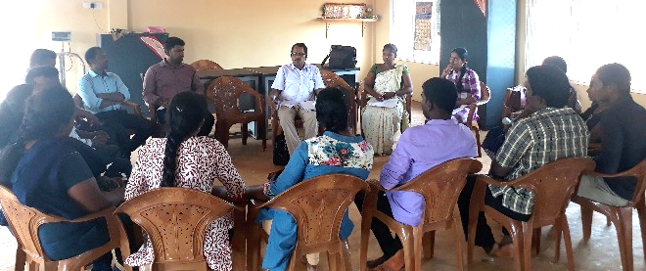
rpWtu; ghJfhg;G gjhijfs; fhl;rpg;gLj;jy;

tlkhfhz ed;dlj;ij ghJfhty; rpWtu; guhkupg;G Nritfs; jpizf;fsk;> Adpnrt; epWtdk; kw;Wk; nrhz;l; epWtdk; ,ize;J mz;ikapy; aho; khtl;lj;jpd; gy;NtW gFjpfspYk; rpWtu; eyd;fis cs;slf;fpa fUj;Jf;fis nfhz;l gjhijfs; kf;fspd; rpe;jidia J}z;Lk; tz;zk; fhl;rpg;gLj;jg;gl;ld.
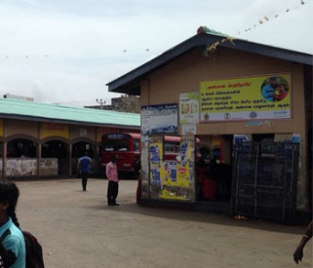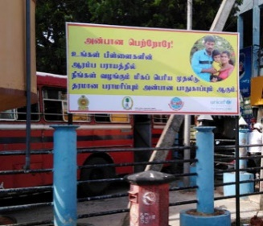
[g;ghd; ehl;bd; JICA epWtdj;jpd; aho;g;ghzj;jpw;fhd tp[ak;

[g;ghd; ehl;bd; JICA epWtdj;jpd; Kfhikj;Jt MNyhrfu; fRNfh rpwha;> tptrha nghwpapayhsu; nfhfp kw;Rlh> xUq;fpizg;ghsu; nrduj;.b.nrha;rh MfpNahu; ,yq;ifapd; tlgFjpahd aho; kz;zpw;F tp[ak; nra;jpUe;jdu;.
ag;ghd; ehl;bd; cjtpAld; ,yq;ifapy; tptrha cw;gj;jpfis epahakhd tpiyf;F re;ijg;gLj;Jjy; njhlu;ghd jpl;lj;ij 5 Mz;LfSf;F nraw;gLj;Jtjw;F jpl;lkpLtjw;fhd jfty;fis jpul;Ltjw;fhf tUifje;jdu;.
,tu;fspd; tUifapd; NghJ SOND epiwNtw;Wg; gzpg;ghsu; jpU.r.nre;Juhrh kw;Wk; SOND gzpahsu;fSldhd fye;Jiuahly; SOND epWtdj;jpy; eilngw;wJ. mjid njhlu;e;J aho; khtl;l tptrhaj; jpizf;fsj;jpy; gpujpg; gzpg;ghsu; kw;Wk; tptrhaj; jpizf;fs cj;jpNahfj;ju;fs; kw;Wk; tptrha rk;Nksdj;jpd; gpujpepjpfSldhd fye;Jiuahly; eilngw;wJ.
NkYk; tptrha cw;gj;jpfs; eilngWk; ,lq;fshd msntl;b> ehtw;Fsp Nghd;wtw;wpw;Fk;> Nfhg;gha;> msntl;bapYs;s tptrha nghUl;fspd; nkhj;jf; nfhs;tdT epiyaq;fisAk; ghu;itapl;ldu;.
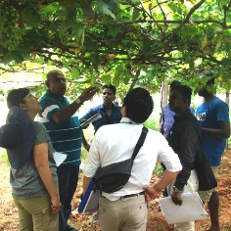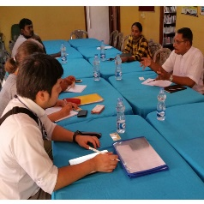
AGSJR epWtdg; gzpahsu;fSf;fhd gapw;rp
r%f ePjpf;Fk; cupikf;Fkhd khw;Wj;jiyKiw (AGSJR) epWtdj;Jld; mgptpUj;jpf;fhd r%f mikg;Gf;fspd; tiyaikg;G (SOND) epWtdk; ,ize;J Gjpa xU khw;wj;ij r%fj;jpy; Vw;gLj;Jk; Kfkhf AGSJR epWtdg; gzpahsu;fSf;Fk;> SOND epWtd gzpahsu;fSf;Fkhd Muk;g ehs; gapw;rp SOND epWtd epiwNtw;Wg; gzpg;ghsu; jpU.r.nre;Juhrh mtu;fshy; AGSJR epWtdj;jpy; elhj;jg;gl;lJ.
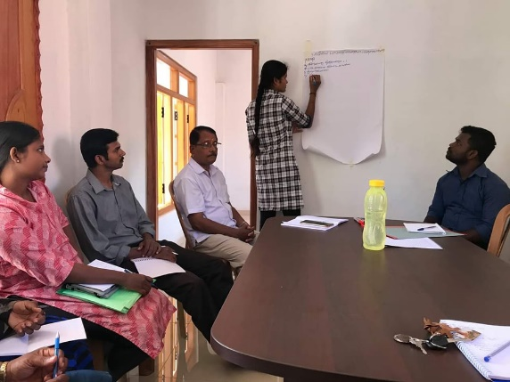
epiykhWfhy ePjp nraw;ghl;L epfo;T

Njrpa rkhjhdg; Nguitapd; epiykhWfhy ePjp njhlu;ghd nraw; jpl;lj;jpd; fPo; nrhz;l; epWtdj;jpd; Vw;ghl;by; ,wf;fhkj;jpy; eilngw;w epfo;tpy; nrhz;l; epWtdj;jpd; epiwNtw;Wg; gzpg;ghsu; jpU.r.nre;Juhrh mtu;fs; jiyik jhq;fpdhu;.
epfo;tpy; fye;Jnfhz;l fpwp];jt ghjpupahu;> nksytp Nghd;NwhUf;F Fu;uhd; rpq;fs nkhopngau;g;G gpujpfs; toq;fg;gl;lJ.
,wf;fhkk; K];ypk; tpj;jpahya khztu;fspd; Nfhyhl;lk; fpq;Fuhd kfsPupDila rkhjhd FOg;ghly;> jk;gpYtpy; rpWtu;fspd; fiy epfo;r;rp> fy;Kid ,isQu; FOf;fspd; eldk; Nghd;w epfo;r;rpfSk; eilngw;wd.
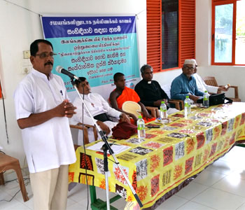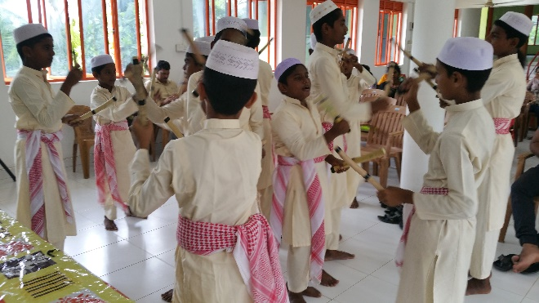
,yq;ifapy; kdpj tpahghuj;jpw;F vjpuhd Kaw;rpfis tYg;gLj;jy; nraw;jpl;lj;jpD}lhf rhtfr;Nrup gpuNjr nrayf cj;jpNahfj;ju;fSf;F xU ehs; gapw;rp eilngw;wJ.

,yq;ifapy; kdpj tpahghuj;jpw;F vjpuhd Kaw;rpfis tYg;gLj;jy; nraw;jpl;lj;jpD}lhf rhtfr;Nrup gpuNjr nrayf cj;jpNahfj;ju;fSf;F xU ehs; gapw;rp eilngw;wJ.
,g; gapw;rp newpapy; fpuhkNritahsu;fs;> gpuNjr nrayf cj;jpNahfj;ju;fs;> kw;Wk; FLk;g ey cj;jpNahfj;ju;fs;> nghyp]; cj;jpNahfj;ju;fs; MfpNahu; fye;J nfhz;ldu;.
,g;gapw;rpapy; tsthsu;fshf nrhz;l; epWtd epiwNtw;Wg; gzpg;ghsu; jpU.r.nre;Juhrh mtu;fSk; ntspehl;L Ntiytha;g;G mYty;fs; (khtl;l ,izg;ghsu;) jpU.T.D.G.gpuhq;fpypd; mtu;fSk; fye;J nfhz;ldu;.
,g;gapw;rpapy; kdpj tpahghuk; njhlu;ghd tplaq;fs; gq;Fgw;Wdu;fSf;F njspTgLj;jg;gl;lJ.
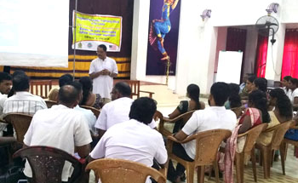
SCORE jpl;lj;jpd; Gjpa jpl;l cj;jpNahfj;jupd; Kd;dpiyapyhd mwpKff; $l;lk;

SCORE jpl;lj;jpd; Gjpa jpl;l cj;jpNahfj;jupd; mwpKff; $l;lkhdJ njy;ypg;gis gpuNjr nrayfj;jpy; eilngw;wJ. ,f; $l;lj;jpy; nrhz;l; epiwNtw;Wg; gzpg;ghsu; jpU.r.nre;Juhrh> nrhz;l; gzpahsu;fs;> kw;Wk; r%f ,izg;ghsu;fSk; fye;J nfhz;ldu;.
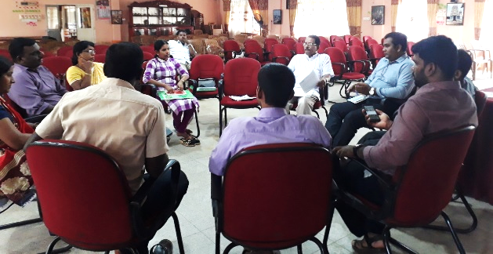
,yq;ifapy; kdpj tpahghuj;jpw;F vjpuhd Kaw;rpfis tYg;gLj;jy; nraw;jpl;lj;jpD}lhf rz;bypg;gha; gpuNjr nrayf cj;jpNahfj;ju;fSf;F xU ehs; gapw;rp eilngw;wJ.

,g; gapw;rp newpapy; gpuNjr nrayhsu; U.aNrhjh mtu;fSk;> cjtpj; jpl;lkply; gzpg;gsu; N.ru;Nt];tud; mtu;fSk; kw;Wk; fpuhkNritahsu;fs;> gpuNjr nrayf cj;jpNahfj;ju;fs;> FLk;g ey cj;jpNahfj;ju;fs;> nghyp]; cj;jpNahfj;ju;fs; MfpNahu; fye;J nfhz;ldu;.
,g;gapw;rpapy; tsthsu;fshf nrhz;l; epWtd epiwNtw;Wg; gzpg;ghsu; jpU.r.nre;Juhrh mtu;fSk; ntspehl;L Ntiytha;g;G mYty;fs; khtl;l ,izg;ghsu; jpU.T.D.G.gpuhq;fpypd; mtu;fSk; fye;J nfhz;ldu;.
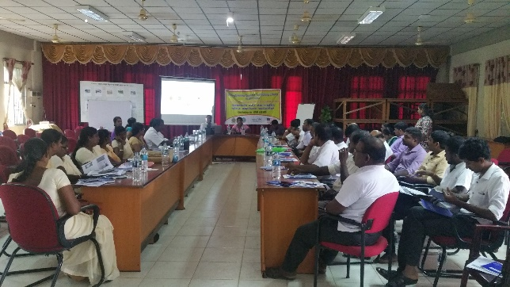
SCORE jpl;lj;jpd; fpuhk kl;l nraw;ghLis jpl;lkpLtjw;fhd $l;lk;

SCORE jpl;lj;jpd; fpuhk kl;l nraw;ghLis jpl;lkpLtjw;fhd $l;lk; njy;ypg;gis gpuNjr nrayfj;jpy; cjtpj; jpl;lkply; gzpg;ghsu;; jiyikapy; eilngw;wJ.
,f; $l;lj;jpy; xt;nthU fpuhkj;jpw;Fk; 2 nraw;ghLfs; tPjk; jpl;lk; eilKiwg;gLj;jggLk; 5 fpuhkq;fSf;Fkhf 10 nraw;ghLfs; jpl;lkplg;gl;lJ. mj;Jld; 5 fpuhkq;fisAk; cs;slf;fpa 2 nghJ epfo;Tk; ,f; $l;lj;jpy; jpl;lkplg;gl;lJ.
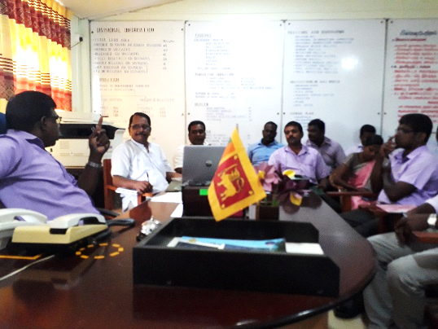
SCORE jpl;lj;jpd; fPo; ,sthiy tl Nkw;fpy; tPjp ehlfk;

,sthiy tlNkw;F gFjpapy; r%f xw;Wik kw;Wk; ey;ypzf;f eltbf;iffis nraw;gLj;Jk; tifapy; 5 tPjp ehlfq;fs; nrk;Kfk; Mw;Wif FOtpduhy; elhj;jg;gl;lJ.
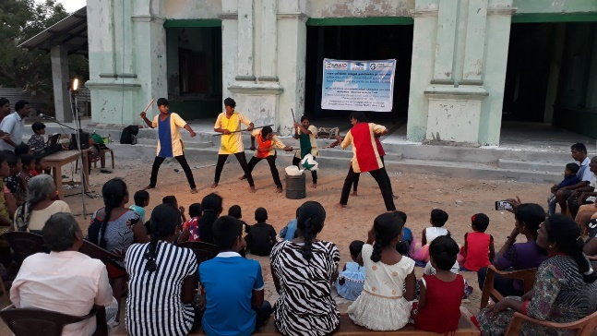
SCORE jpl;lj;jpd; DAP kPsha;T $l;lk;

SOND epWtdj;jpd; Vw;ghl;by; Njrpa rkhjhdg; Nguitapd; SCORE jpl;lj;jpd; gpuNjr kl;l MNyhridf; FO kPsha;Tf; $l;lkhdJ njy;ypg;gis gpuNjr nrayf cjtpj; jpl;lkply; gzpg;ghsu; jiyikapy; eilngw;wJ.
,jpy; SCORE jpl;lj;jpd; jpl;l cj;jpNahfj;juhd G.Wotkinson mtu;fs; jpl;l nraw;ghLfs; njhlu;ghf tpsf;fkspj;jhu;.

mur rhu;gw;w epWtdq;fspd; rl;l jpUj;jk; njhlu;ghd fye;Jiuahly; nfhOk;gpy; eilngw;w NghJ………

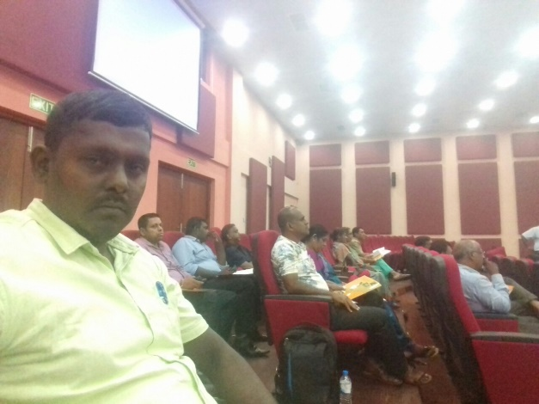
USAID ,d; jpl;lk; njhlu;ghd $l;lk; nfhOk;gpy; eilngw;w NghJ………

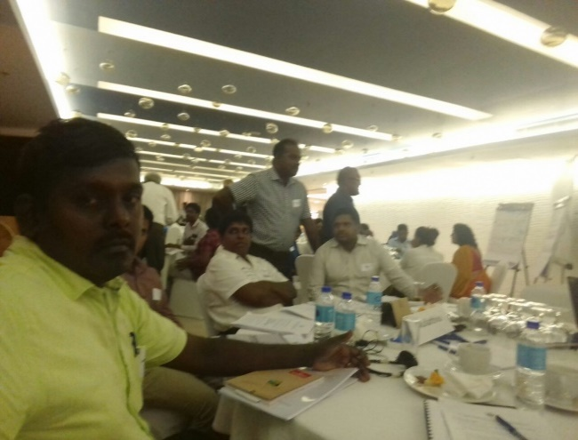
,yq;ifapy; kdpj tpahghuj;jpw;F vjpuhd Kaw;rpfis tYg;gLj;jy; nraw;jpl;lj;jpD}lhf aho;g;ghz gpuNjr nrayf mur mjpfhupfSf;fhd xU ehs; gapw;rp

,yq;ifapy; kdpj tpahghuj;jpw;F vjpuhd Kaw;rpfis tYg;gLj;jy; nraw;jpl;lj;jpD}lhf aho;g;ghz gpuNjr nrayf mur mjpfhupfSf;fhd xU ehs; gapw;rp newpahdJ aho;g;ghz gpuNjr nrayf gapw;rp epiyaj;jpy; eilngw;wJ.
,g; gapw;rp newpapy; fpuhkNritahsu;fs;> gpuNjr nrayf cj;jpNahfj;ju;fs;> FLk;g ey cj;jpNahfj;ju;fs;> nghyp]; cj;jpNahj;ju;fs; MfpNahu; fye;J nfhz;ldu;.
,g;gapw;rpapy; tsthsu;fshf nrhz;l; epWtd epiwNtw;Wg; gzpg;ghsu; jpU.r.nre;Juhrh mtu;fSk; rz;bypg;gha; gpuNjr nrayf ntspehl;L Ntiytha;g;G mgptpUj;jp cj;jpNahfj;ju; jpUkjp.S.wh[pdp mtu;fSk; fye;Jnfhz;ldu;.
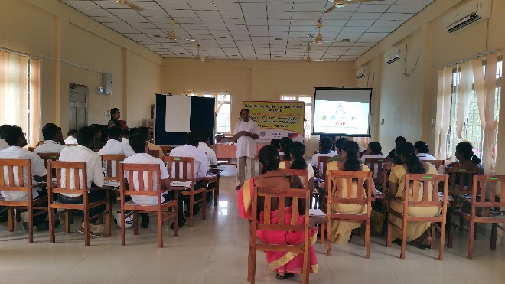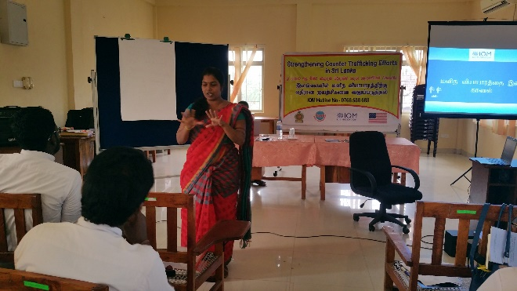
,yq;ifapy; kdpj tpahghuj;jpw;F vjpuhd Kaw;rpfis tYg;gLj;jy; nraw;jpl;lj;jpD}lhf rhtfr;Nrup gpuNjr ,isQu;fSf;fhd xU ehs; gapw;rp
,yq;ifapy; kdpj tpahghuj;jpw;F vjpuhd Kaw;rpfis tYg;gLj;jy; nraw;jpl;lj;jpD}lhf ey;Y}u; gpuNjr fpuhk kl;l mikg;Gf;fspd; gpujpepjpfSf;fhd xU ehs; gapw;rp

,yq;ifapy; kdpj tpahghuj;jpw;F vjpuhd Kaw;rpfis tYg;gLj;jy; nraw;jpl;lj;jpD}lhf ey;Y}u; gpuNjr nrayf fpuhk kl;l mikg;Gf;fspd; gpujpepjpfSf;fhd xU ehs; gapw;rp newpahdJ A+Nuhtpy; kz;lgj;jpy; eilngw;wJ eilngw;wJ.
,g;gapw;rpapy; tsthsu;fshf nrhz;l; epWtd epiwNtw;Wg; gzpg;ghsu; jpU.r.nre;Juhrh mtu;fSk; nry;tp.R.jhl;rhapdp mtu;fSk; fye;Jnfhz;ldu;.
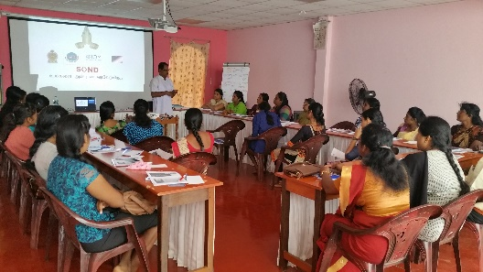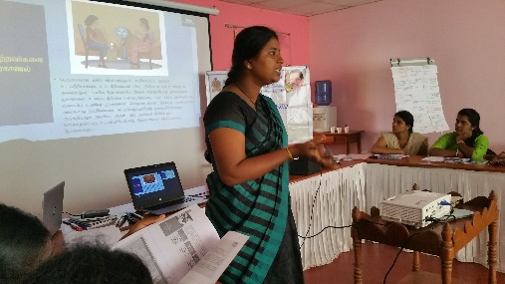

,yq;ifapy; kdpj tpahghuj;jpw;F vjpuhd Kaw;rpfis tYg;gLj;jy; nraw;jpl;lj;jpD}lhf rhtfr;Nrup gpuNjr ,isQu;fSf;fhd xU ehs; gapw;rp newpahdJ gpuNjr nrayf kz;lgj;jpy; eilngw;wJ.
,g;gapw;rpapy; tsthsu;fshf nrhz;l; epWtd epiwNtw;Wg; gzpg;ghsu; jpU.r.nre;Juhrh mtu;fSk; jpUkjp.S.bNdrpah mtu;fSk; fye;Jnfhz;ldu;.
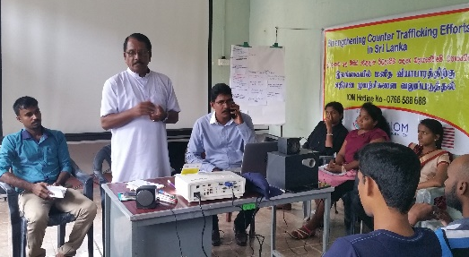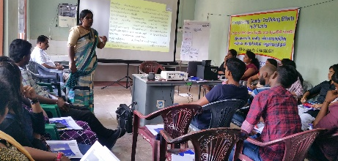
fpof;F gy;fiyf;fof khztu;fSf;fhd Mq;fpy nkhop %y MSik tpUj;jp gapw;rp

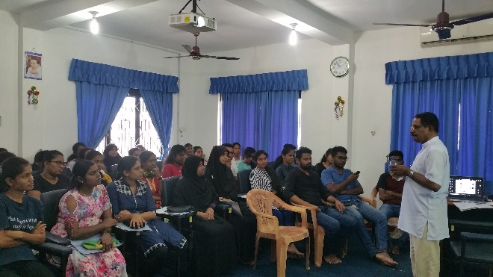
fpof;F gy;fiyf;fofj;jpd; njhopy; topfhl;ly; gpuptpd; Vw;ghl;by; tptrha gPl 2Mk; Mz;L khztu;fSf;fhd Mq;fpy nkhop %y MSik tpUj;jp gapw;rp jkpo;> rpq;fs khztu;fSf;F nrhz;l; epWtd epiwNtw;Wg; gzpg;ghsu; jpU.r.nre;Juhrh mtu;fshy; elhj;jg;gl;lJ.

